May 7, 2013

Dear Members:

Caregivers are the backbone to our senior care system, but they are underpaid. Year after year we lobby for increased reimbursement rates so that we can put more money in the pockets of caregivers. This year is no different, and SF 792 (Eken), which has broad bi-partisan support, proposes increasing Medicaid rates by 5% in each year of the biennium so we can better pay our caregivers. However, raising the state minimum wage rate raises a different challenge for senior providers as the current bills SF 3 (Eaton) and HF 92 (Winkler) do not address the lack of funding mechanism.

Our concerns are unique because unlike any other business, Minnesota’s nursing homes and other senior care providers are constrained in their ability to raise revenues by what state lawmakers appropriate. In the case of nursing homes, our state law called rate equalization provides that a nursing home cannot charge private pay clients a higher rate than the designated Medicaid rate. Many other senior care providers, such as assisted living and home care providers, serve a population so dependent on Medicaid that there are not private pay dollars to cover the costs associated with increasing the minimum wage.

Moreover, Minnesota’s senior care system has been chronically underfunded for years. As a result, Medicaid rates are already woefully inadequate to cover costs. We estimate that the current levels of nursing home funding fall nearly $28 per resident per day below allowable Medicaid costs. This is why we introduced legislation that would increase Medicaid rates by 5% in each year of the biennium for nursing homes and home care settings (SF792 (Eken)). Our funding request was designed to make up for some of these current funding shortfalls. If the minimum wage is increased, it is likely that additional funding above that which we introduced will be needed.

Right now, most senior care providers are already conforming to the higher federal minimum wage due to the way they receive funding. However, if the Senate were to move beyond federal conformity and increase the state minimum wage to the level proposed in HF 92 of $9.50 per hour, we estimate it would cost nursing homes an estimated $12.4 million beginning August 1, 2015. Without a mechanism to increase reimbursement rates as the minimum wage would increase, nursing homes and senior care providers will have little choice but to lay off staff, reduce hours, suspend admissions, or other cost-cutting measures, all of which will be a detriment to the seniors they serve.

We trust you will consider senior care when discussing the important minimum wage issue. We support the Senate position of federal conformity in SF 3. However, if there are considerations to move beyond federal conformity, we hope that you would also consider adding a funding mechanism to this bill to help nursing homes and senior care providers cover the costs associated with such increases.

Sincerely,

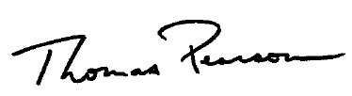
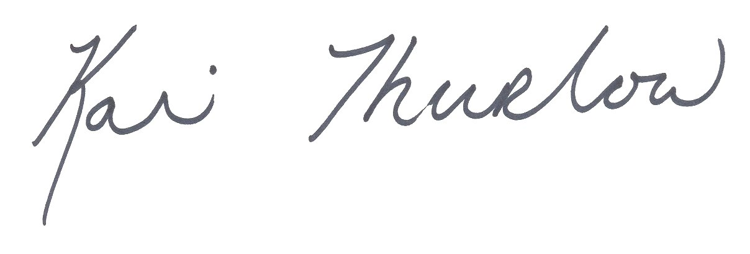

Toby Pearson Kari Thurlow
Vice President of Advocacy Vice President of Advocacy
Care Providers of Minnesota Aging Services of Minnesota

